 |  | 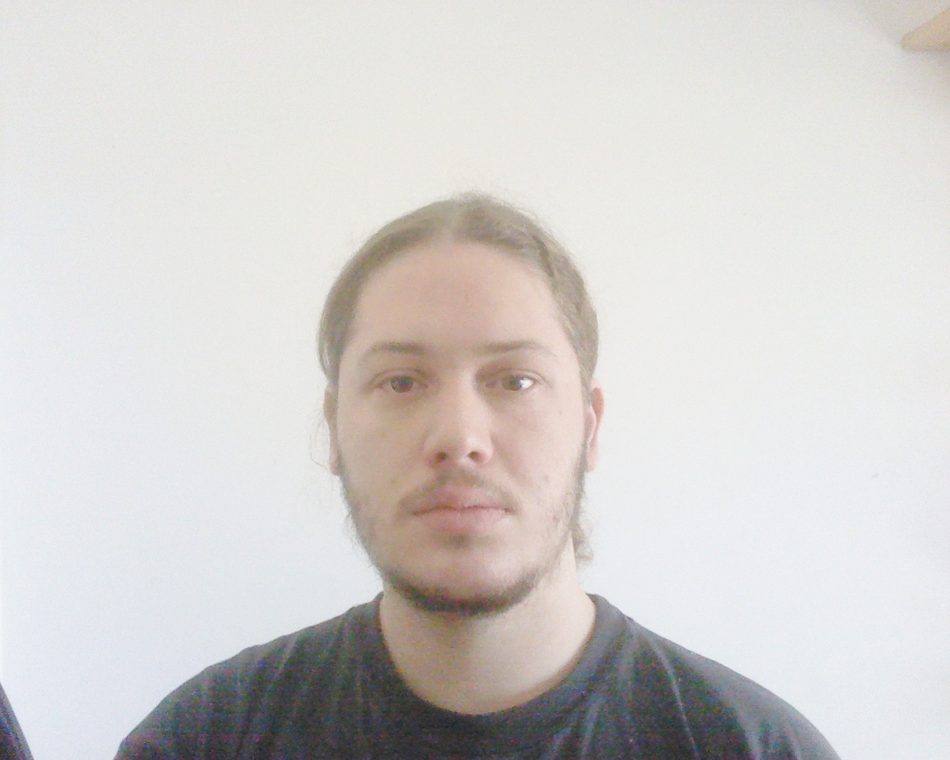
Curriculum Vitae
Personal information
First name(s) / Surname(s) |  | Thomas Abela
Address |  | 1, Edmond Halley Street, MLH 2650 Mellieha (Malta)
Telephone(s) |  | 21521420 |  |  |  |  | Mobile |  | 99058911
E-mail(s) |  | tom_abela@hotmail.com
Nationality |  | Maltese
Date of birth |  | 14.3.91
Gender |  | Male
Desired employment / Occupational field |  | Group Leader
Work experience
Dates |  | 06/2007 - 09/2007
Occupation or position held |  | Receptionist
Main activities and responsibilities |  | Handling bookings, minimarket and stock. Occasionally cooking for and serving customers in the onsite Restaurant
Name and address of employer |  | Malta Campsite  Dahlet ix-Xmajjar, Limiti tal-Mellieha, MLH 7500 Mellieha (Malta)
Type of business or sector |  | Accommodation and food service activities
Dates |  | 06/2008 - 08/2008
Occupation or position held |  | Waiter
Main activities and responsibilities |  | Taking orders, serving food and beverages.
Name and address of employer |  | L'Escargot Restaurant  5, Triq Gorg Borg Olivier, Mellieha (Malta)
Dates |  | 07/2009 - 08/2009
Occupation or position held |  | Summer School Carer
Main activities and responsibilities |  | Accompanying Children during outings.
Name and address of employer |  | Maria Regina College  St.Paul's Bay Primary School Street, SPB09 St.Paul's Bay (Malta)
Type of business or sector |  | Education
Dates |  | 06/2012 - 12/2012
Occupation or position held |  | Retail Salesman/ Restaurant Host
Main activities and responsibilities |  | Retail - Selling clothing and souvenir items at point of sale, aiding customers in their purchases, cash handling, restocking shelves with products, regular clean-ups of working area.  Host – Taking & managing bookings, greeting customers at entrance and showing them to their tables, ensuring that customers are satisfied with their overall dining experience.
Name and address of employer |  | Hard Rock Café Malta  Level 2, Bay Street Tourist Complex  St George’s Bay, St.Julian’s,  Malta
Type of business or sector |  | Sales/Catering
Dates |  | 07/2013 - 11/2013
Occupation or position held |  | Group Leader
Main activities and responsibilities |  | Accompanying students on daily excursions & activities, supervising activities, ensuring that all students are accounted when arriving or before leaving a location.
Name and address of employer |  | Maltalingua School of English  2 Birkirkara Hill  St. Julian’s  Malta
Type of business or sector |  | Education
Education and training
Dates |  | 09/2002 - 04/2007
Title of qualification awarded |  | Matsec Secondary Education Certificate
Principal subjects / occupational skills covered |  | Maths  English Language  English Literature  Maltese  French  Religion  Computer Studies  Physics
Name and type of organisation providing education and training |  | St. Albert the Great College. (Secondary School)  60, Old Bakery Street, VLT 1457 Valletta (Malta)
Level in national or international classification |  | O level
Dates |  | 08/2007 - 04/2010
Title of qualification awarded |  | A Level Certificate
Principal subjects / occupational skills covered |  | Advanced level –  Information Technology,  Pure maths  Intermediate level –  English  Physics  Philosophy  Systems of Knowledge.
Name and type of organisation providing education and training |  | G.F Abela Junior College  Guze Debono Square, MSD 1252 Msida (Malta)
Personal Skills  Mothertongue  Other language(s) |  | Maltese
Self-assessment |  |  | Understanding |  |  |  | Speaking |  |  |  | W r i t i n g
European level (*) |  |  | Listening |  | Reading |  | Spoken interaction |  | Spoken production
English |  |  | C2 | Proficient user | C2 | Proficient user | C2 | Proficient user | C2 | Proficient user | C2 | Proficient user
 |  | (*) Common European Framework of Reference (CEF) level
Social skills and competences |  | I am an outgoing person, team spirited and eager to meet new people.
Artistic skills and competences |  | I have a passion for art in all forms; I sketch portraits and landscapes varying in themes regularly. I spend a lot of free time working on 2D and 3D computer graphics art.
Computer skills and competences |  | -Good understanding of computing through I.T. education, Good command of Microsoft Office tools, through an ECDL course.  - Currently doing a course with MCAST in computer software and networking.

